GEOL 3305 Chapter 21

Origin of Modern Astronomy

Things are not as they seem

The Earth travels around the sun at 100,000 km/hr (66,000 mi/hr)

The Earth spins once each day, we spin at 1,670 km/hr (1,000 mi/hr)

The Earth hurtles toward the Andromeda galaxy at 400,000 km/hr
(250,000 mi/hr)

And yet we feel as though we are not moving at all.

Therefore most of the ancients felt we were the center of the universe.

The Universe is unbelievably large

If the solar system is the size of an Oreo Cookie, the the closest star (Proxima Centauri) would be 2 football fields away.

And the center of our Milky Way Galaxy would be at Little Rock, Arkansas.

The distance to the next Galaxy (Andromeda) would be 4,000,000 times further than Little Rock, Arkansas (1.8 Billion miles)

Early Greeks

Anaxagoras (500 B. C.)
- Moon is a sphere
- Moon shines by reflected light
Aristotle (384 - 322 B. C.)
- Earth is a sphere
- Evidence was Lunar eclipse shadow
Aristarchus (312 - 230 B. C.)
- Calculated distances to Sun and Moon
- inaccurate distances, but proportion OK
- He did this using a right triangle

- Determined the Sun was larger than Earth and
therefore concluded that the Sun was the center.
Eratosthenes (276 - 194 B. C.) Measured the Size of the Earth.

Geocentric (Ptolemaic 141 A.D. (also C. E.)) (Earth Centered model)
- no sense of motion of the Earth
- Planets, Sun, & Moon orbited Earth
- Stars on Celestial Sphere
- Epicycle used to explain retrograde motion
- Very accurate predictions of position in sky
- Poor physical model
Retrograde motion. Usually the outer planets appear to move
from West to East across the sky from one night to another.

However a short reversal is observed when the Earth passes its
closest point to that planet. This short period of reversal is called retrograde motion.

A clockwork of the solar system was built by Giovanni
de Dondi in Padua about 1350. It accurately predicted the
location of the Sun, Moon, and planets in the sky. This is a copy
which is in the Smithsonian which was built from his plans

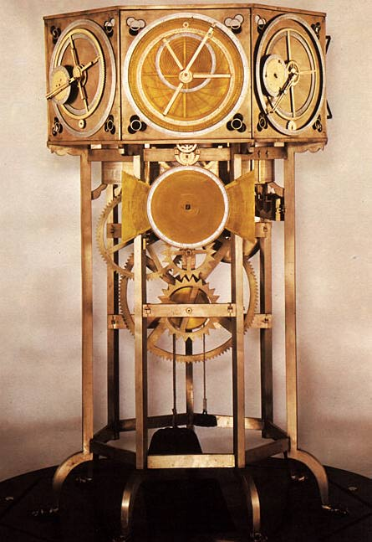

1st book was printed 1452 AD. Before that, books were hand copied.

Copernicus (1473-1543) (Sun Centered model), He discovered the writings of Aristarchus.
- contemporary of Leonardo Da Vinci 1452-1519)
- Earth is a planet
- Used circles, but added epicycles for improved accuracy
- Hired by Catholic Church for calendar reform.
- His book on the mathematical description of the heavens was entitled De Revolutionibus Orbium Coelestium. This eventually caused the modern interpretation of "revolution".

Protestant Reformation in the sixteenth century (1500's)
- 1622 Catholic Church created institution for propagation
of the faith (hence the word: propaganda)

Tycho Brahe (1546-1601)
- Believed in alchemy and astrology.
- On 11 November 1572, he saw a new star in Cassiopeia, a
supernova and this turned his interest back to astronomy.
- Built his observatory in Denmark and measured locations of
planets as a function of time.
- Found no stellar parallax and therefore assumed that the
Earth didn't move.
- Was convinced the Ptolemaic model was correct.

Kepler (1571 - 1630)
- Assistant to Tycho Brahe.
- Modeled planet paths as ellipses
- equal area swept out in equal time (this shows that the planets move faster when they are nearest to the Sun)
- orbital period proportional to distance from Sun.

Bruno was burned at the stake in 1600 for believing the Sun was at the center of the universe.

If you are interested in the history of science, I highly recommend the book "The Ascent of Man" by Jacob Bronowski, Little, Brown and Co., 1973, 6th ed. ISBN 0-316-10930-4

Galileo (1564-1642)

Began development of Physics of Motion

- Used Telescopes for:
- Trade
- Astronomy

-Discovered in 1610
- 4 moons of Jupiter
- planets appear as disks not points like stars
- Venus has phases like the Moon
- Moon has craters, mountains, and plains
- Sun has Sunspots (not perfect)

In 1616 the Catholic Church condemned Copernican Theory

In 1630 the Pope's secretary gave permission to publish

In 1638 last book was published.

Dialogues concerning two new sciences
Mechanics and Local Motion

Newton (1642 - 1727)

Inertia

Thomas Acquinas developed the theory of Impetus
Galileo refined theory
Newton formalized

Newton - Laws of Gravitation, Calculus, Spectroscopy, Inertia
In 1655, Cambridge University was closed due to the Plague.

acceleration = γ M/r2

where γ = universal constant of gravitation
M = mass of body
r = distance from the center of mass

Period of satellite and altitude of satellite,
allows calculation of the mass of the parent body
(e.g. Period and Venus-Sun distance gives the mass of Sun).

Perihelion - that point in the orbit closest to the Sun

Aphelion - that point in the orbit farthest from the Sun

Ecliptic - plane of the Earth's orbit
- also the path of the Sun seen against the Stars

Ecliptic crosses the celestial equator at two points
- Vernal equinox
- autumnal equinox

Rotation - spinning of a body on its axis

Revolution - motion of a body about some point in space

The solar day accounts for the apparent motion of the sun (4 minutes longer).

The sidereal day accounts for the apparent motion of the stars.

The Earth wobbles like a spinning top. This is called precession and a complete wobble takes 26,000 years.

In 1851 Foucault used a free-swinging pendulum to demonstrate that the Earth rotates on its axis.

Moon

Far side of moon -
Moon always has the same side facing the Earth (near side)

Only astronauts and space probes have seen the far side.

Dark side of moon -
Only half of the Moon is illuminated at a time.

New Moon - dark side of the Moon is facing the Earth.

Moon's temperature
Lack of substantial atmosphere
Long solar day (about 14 Earth days)
Long solar night (about 14 Earth days)

Low temperature during solar night = -173 deg C (-279 deg F)
High temperature during solar day = +127 deg C (+260 deg F)

These temperatures are radiant temperatures.

Eclipses

Moon's orbit is inclined 5 degrees relative to ecliptic.
If it wasn't and was exactly in the plane of the Earth's orbit we would have a solar eclipse and lunar eclipse each month.

Lunar & Solar eclipses can occur only when:
- Moon is in the ecliptic plane
- New Moon (solar eclipse)
- Full Moon (Lunar eclipse)

- Lunar eclipses
- visible over half of the Earth
- lasts about 4 hours

- Solar eclipses

-region on Earth less than 170 miles wide

- total eclipse only occurs when the Moon is at the
distance from the Earth to just exactly cover the Sun.

- annular eclipse – When the Moon doesn’t completely cover the Sun. This occurs when the Moon is farther from Earth than for a total eclipse.
- Due to tidal forces the moon is receeding from the Earth.
- This causes annual eclipses to be more common.

The next total solar eclipses in the U. S.

Aug 21, 2017 (Salem Oregon)

April 8, 2024 (Mexico, U. S. & Canada)

Go to Austin or Dallas to see it.

Path of totality goes from the SW toward the NE from Kerrville to Waxahatchie, TX.

See http://www.earthview.com/timetable/futureTSE.htm for a table of future solar eclipses

Other sites discussing solar eclipses:

http://www.mreclipse.com/Special/SEprimer.html
http://homepage.ntlworld.com/rimonk/eclipse/pushpins/pushpins.htm
http://www.thursdaysclassroom.com/12aug99/2017_lessonplan.htm
http://www.mcglaun.com/eclipses.htm#Stories
http://www.eclipse-chasers.com/

Hints of a solar eclipse in Homer's epic 40 day voyage the "Odyssey", references to the planets: Mercury and Venus, the "new moon" and the constellation Peiades and Bootes indicate that all this only occurs once every 2,000 years.

This gives credence that the Odyssey may have been a real voyage and Odysseus may have ended this journey on April 16, 1178 B.C.E.

The Olympic games started in 776 B. C. E.

Ref: Science June 27, 2008, page 1701

